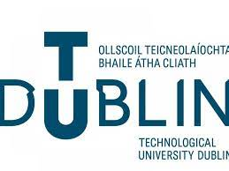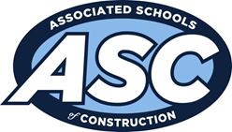
Region 8 International Student Competition
The Associated Schools of Construction (ASC) Region 8 International Student Competition 2024 hosted by the School of Surveying & Construction Innovation, TU Dublin opened on Wed 6th Nov 2024.
The 10th year of the competition saw a record 23 teams from 15 European, UK and American Universities compete across three tracks: Construction Management & Quantity Surveying, Project Management and Design & Build.
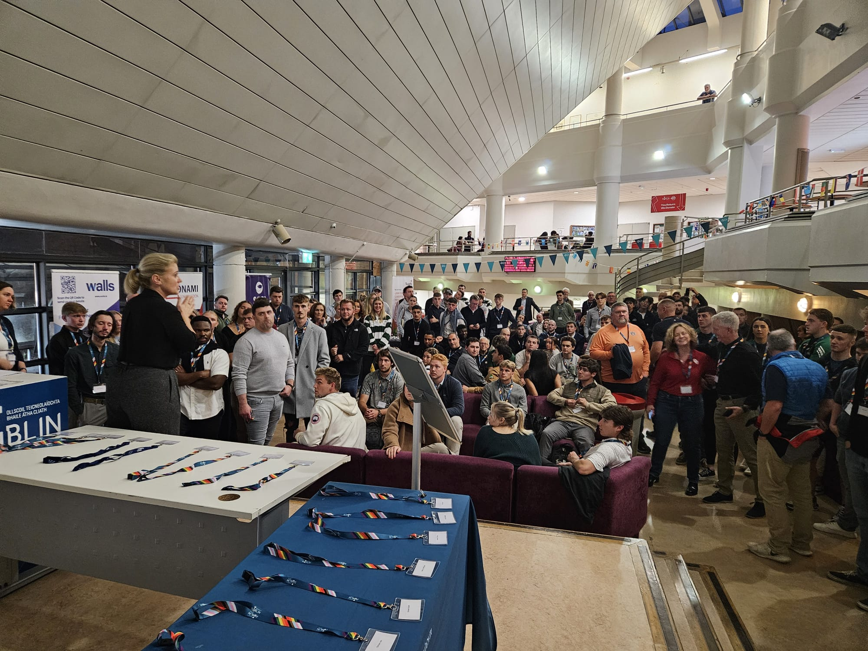
The event brought together over 100 top construction management and built environment students from around the world to showcase their skills and knowledge.
• TU Dublin students who got the opportunity to compete: 13
• Visiting coaches from national and international universities: 32
• Industry sponsors and representatives: 16

This year’s participants came from: Technological University Dublin, Dundalk Institute of Technology, University of Limerick, Munster Technological University, Liverpool John Moores University, Czech Technological University, California Polytechnic State University (Cal Poly), Auburn University, University of Oklahoma, University of Denver, Virginia Tech University, Boise State University, Roger Williams University, California State University, Chico, University of Southern California.
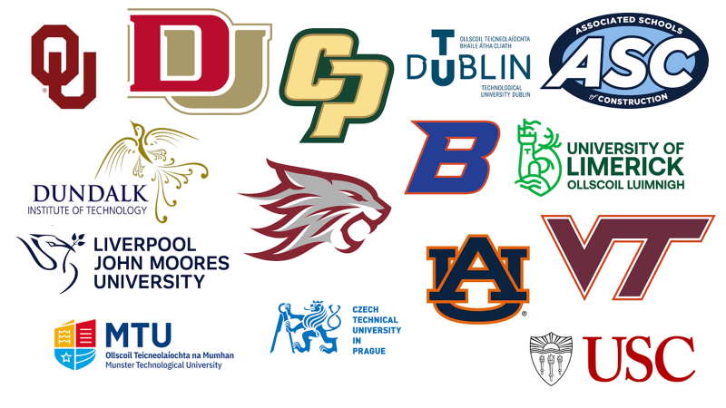
All teams were presented with a real-life construction industry project in each track, where they were asked to prepare and present strategic contributions covering key project elements such as: Construction Programme, Site Strategy, Layouts and Logistics, Risk and Quality Management, and Estimating to name only some. Each team then had the opportunity to present their findings to the industry expert panel, this was then followed by an in-depth Q&A session. The competition closed on the 8th of Nov 2024 with the awards reception taking place in the Four-Star Iveagh Garden Hotel, Dublin 2.
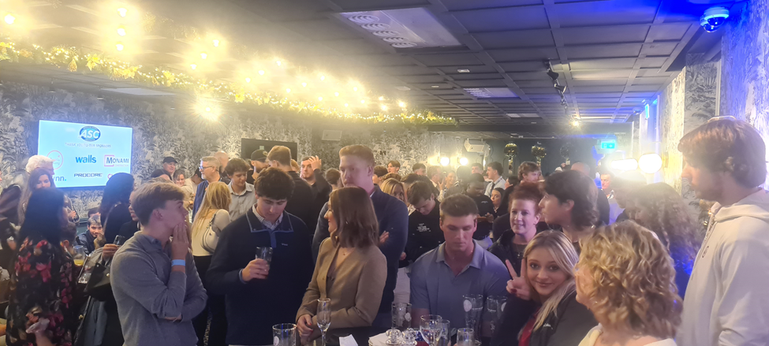
Congratulations to all teams, students and coaches who participated across three days of tough competition and to the eventual winners of each track:
Design & Build – Sponsored by Monami
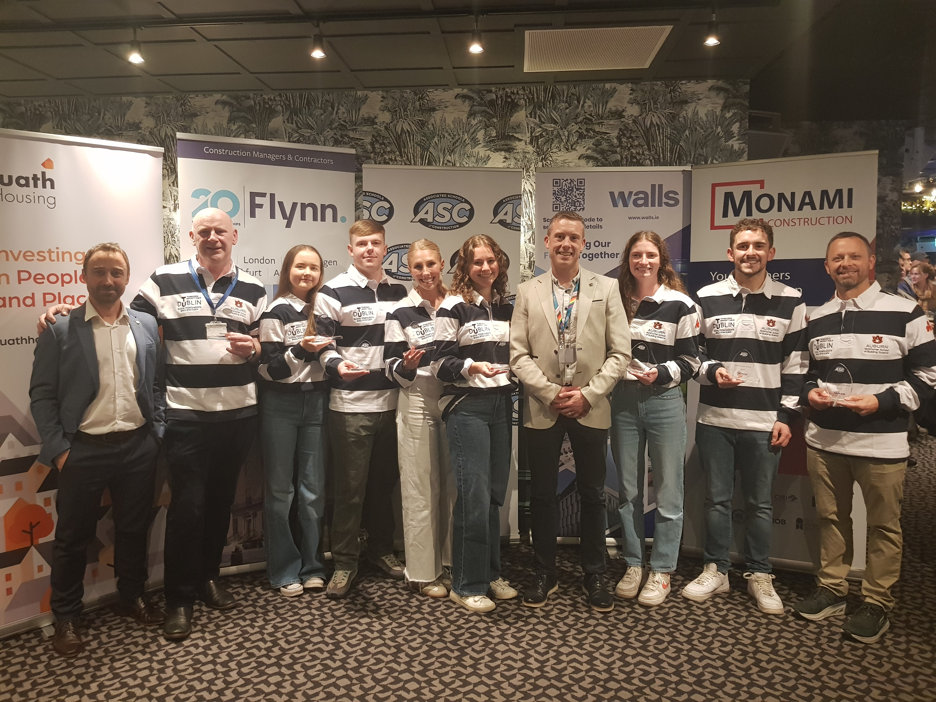
1st Place -Technological University Dublin / Auburn University
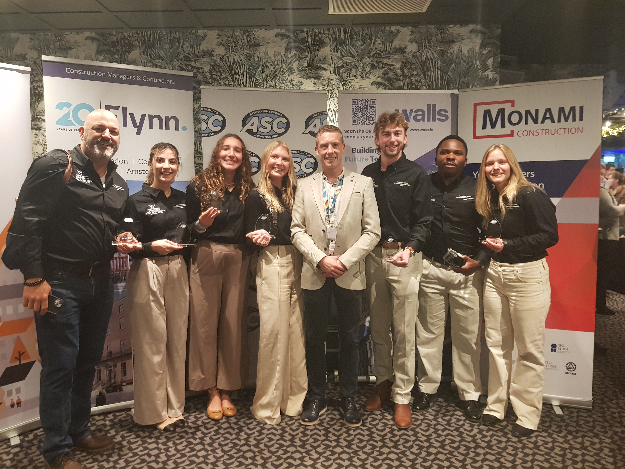
2nd Place -Virgina Tech University
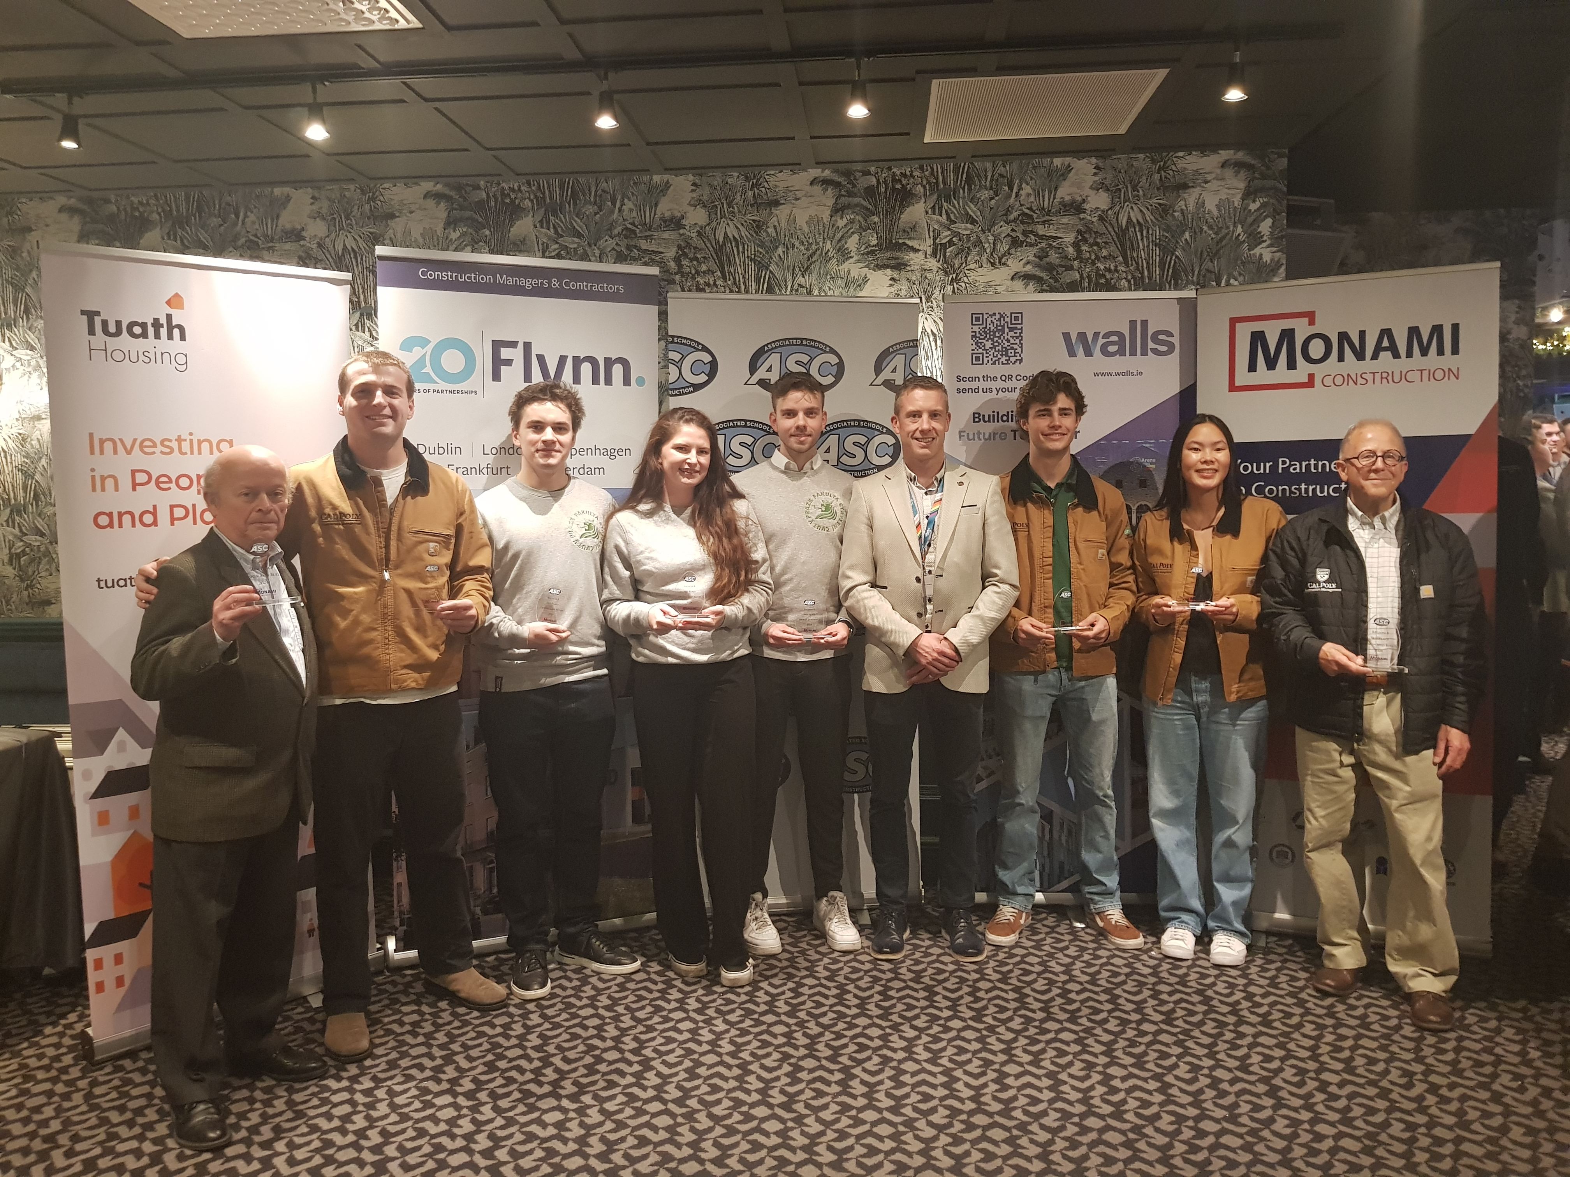
3rd Place -Czech Tech/Calpoly
Project Management – Sponsored by Flynn
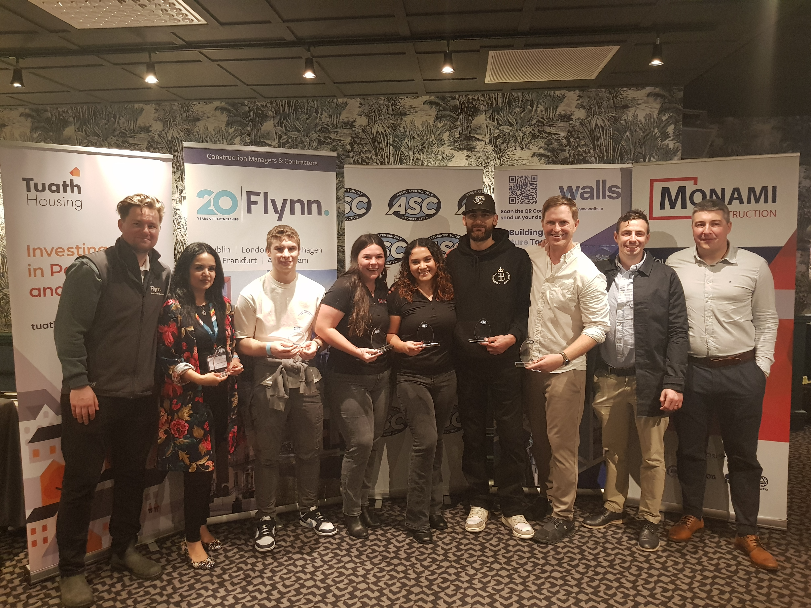
1st Place -LJMU/Chico
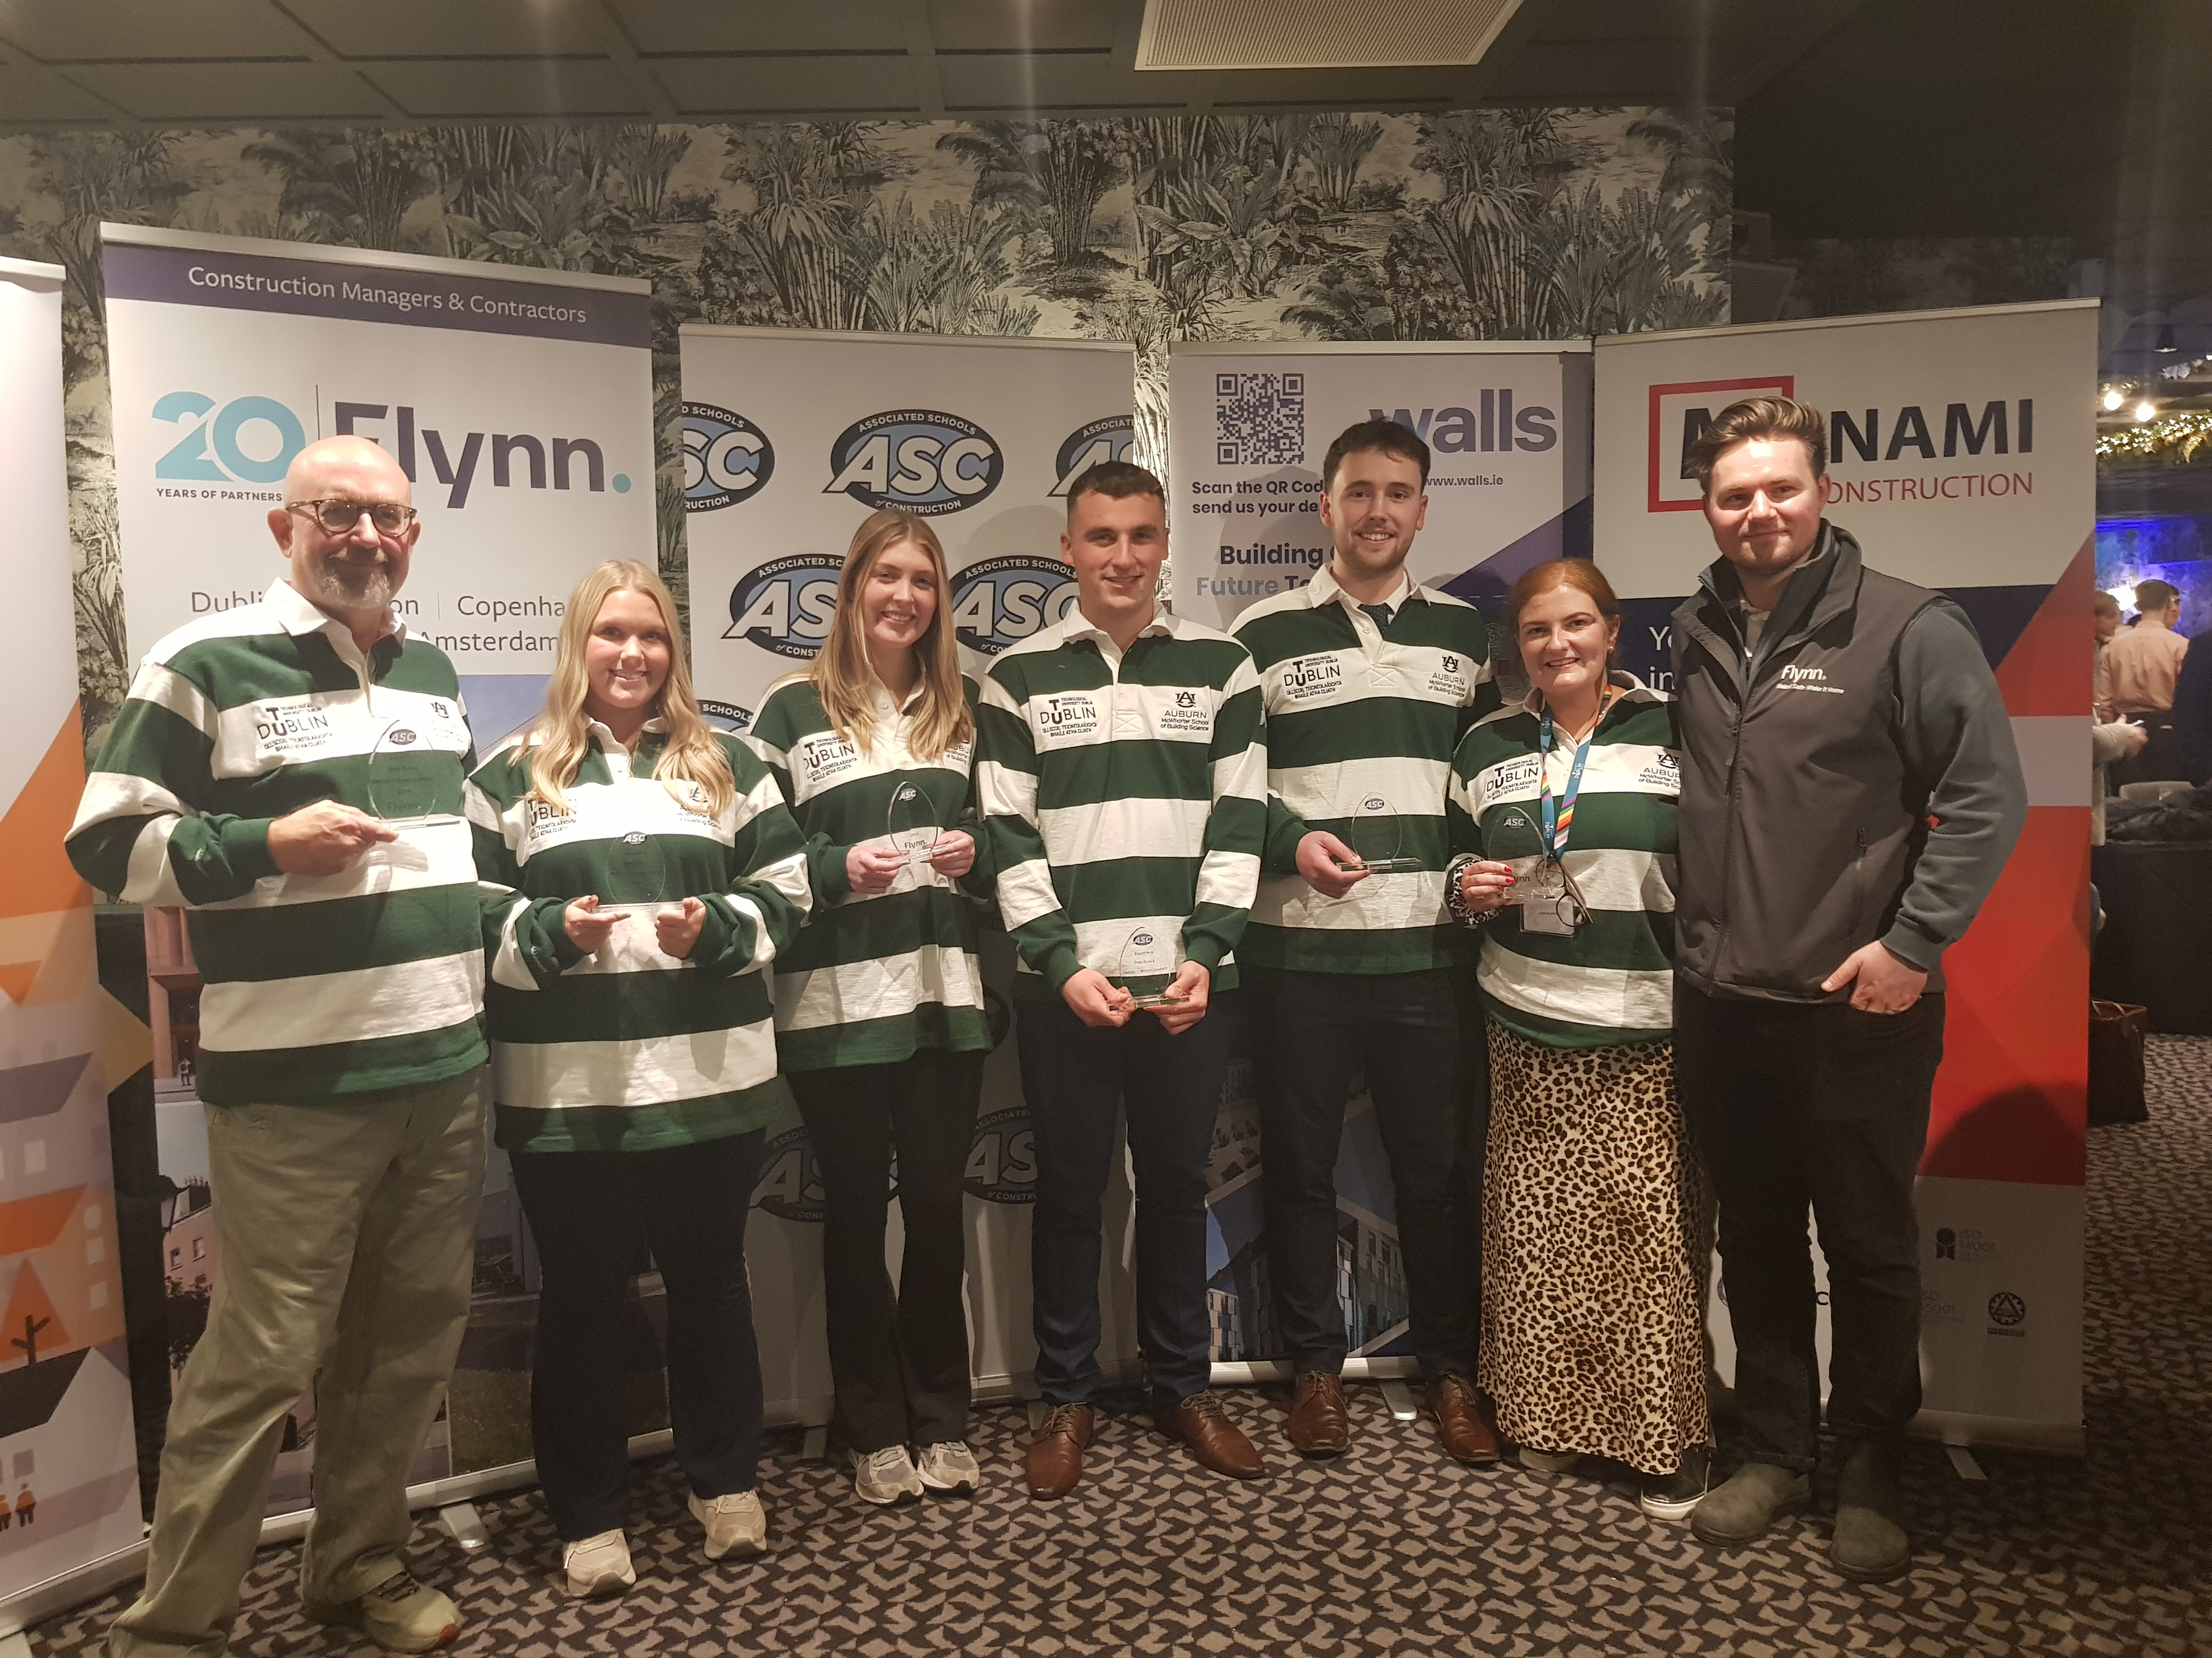
2nd Place -TuD/Auburn
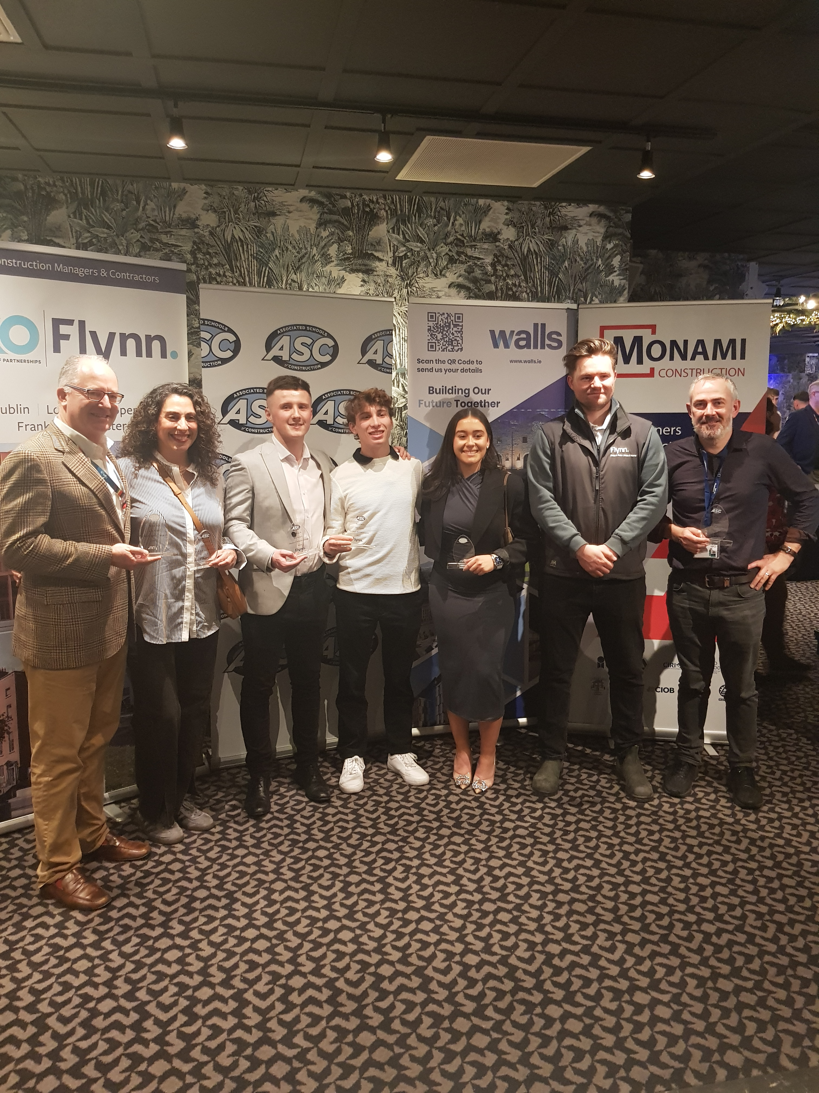
3rd Place -TuD/Denver
Construction Management – Sponsored by Walls
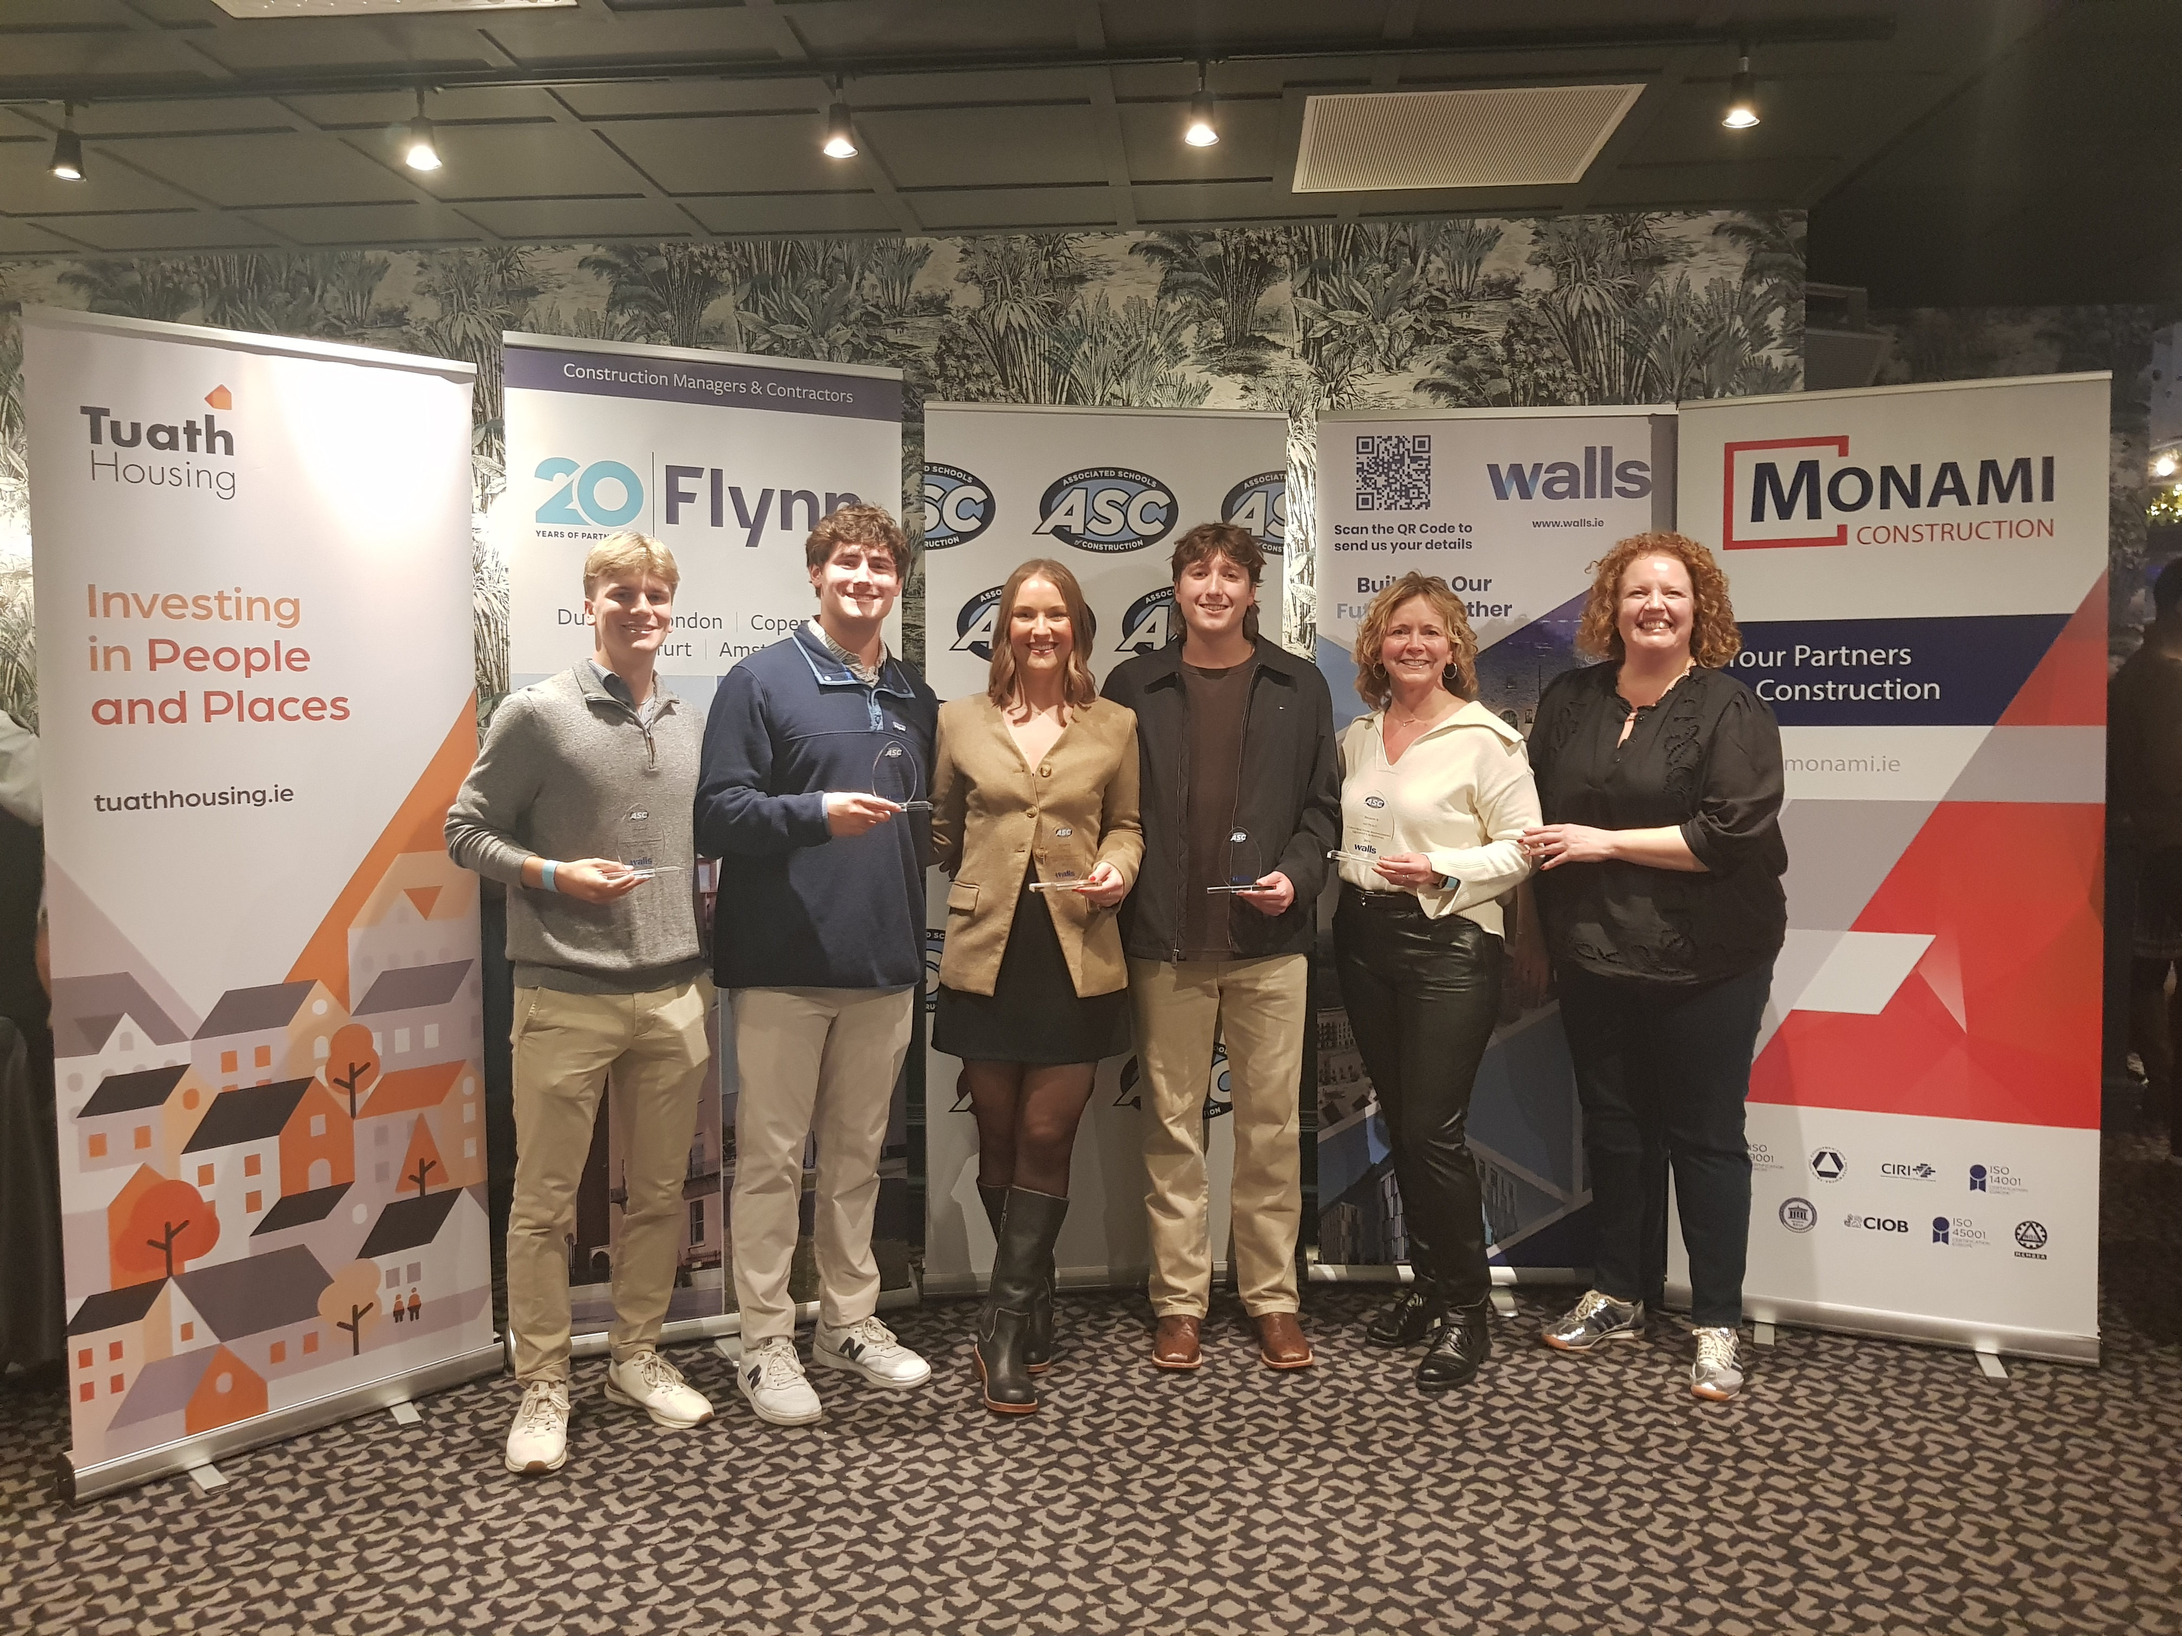
1st Place -OU
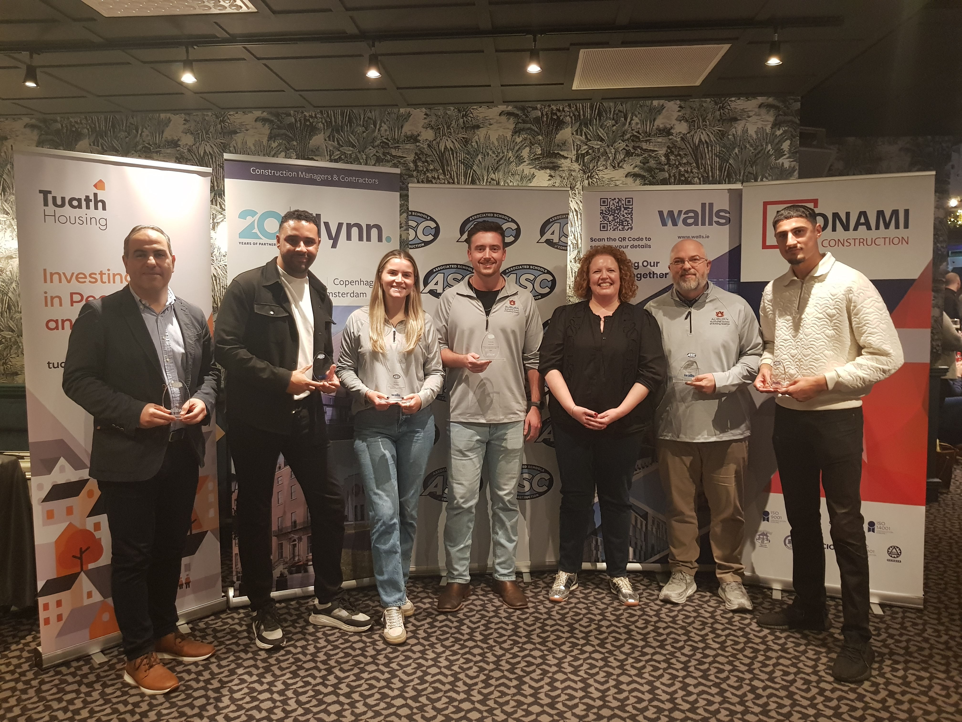
2nd Place -LJMU/Auburn
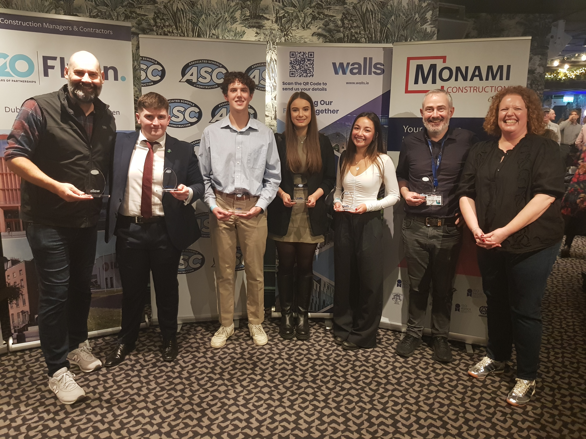
3rd Place -TuD/Boise

Finally, the biggest thank you to our sponsors Flynn Management & Contractors, Walls Construction Limited, Monami Construction, Clancy Construction, Procore Technologies and Tuath Housing Association. Without their support and input, this competition would simply not have happened.
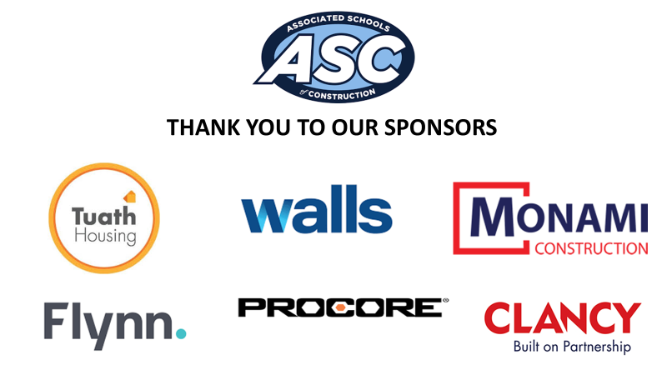

If you are a University (with a relevant programme) or a Construction Contractor or Consultancy interested in getting involved with next year’s competition, please feel free to get in touch with any of our organising committee:
Sonya Meekel (ASC Region 8 Director) - sonya.meekel@tudublin.ie
Jimi Johnston – jimi.johnston@tudublin.ie
Joanne White – Joanne.white@tudublin.ie
Dr. Patrick Bruce -Patrick.bruce@tudinlin.ie

