

**ASC Region 8**

**International Student Competition 2016**

1. **Introduction**

The ASC Region 8 2016 International Student Competition is being hosted by the University of Reading on November 17th – 18th. The two-day competition will be held on the University campus. Registration will be held at Park House (see image below) on Thursday 17th November at 9.30am, with refreshments and lunch provided during the day, and presentations on Friday 18th November in the Meadow Suite.

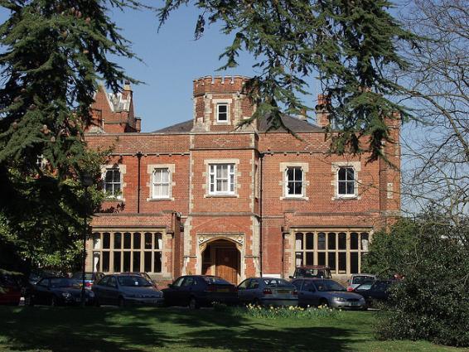

Park House – The University of Reading

1. **Outline of the project**

The construction project is located on the outskirts of the University campus, part of a halls that has been redeveloped. There will be a number of challenges associated with the project, and various health and safety issues that require attention.

On the day, a pack of detailed information containing site layouts and architectural drawings will be issued to each group of students involved in the Region 8 challenge.

Site location:

[Link to Google Maps of the project](https://www.google.co.uk/maps/place/Bridges+Hall+JCR/@51.441959,-0.937468,17z/data=!4m5!3m4!1s0x487684b12a855d2d:0xd065ac3c6c797854!8m2!3d51.4427354!4d-0.9364651)

[Link to Google Maps image of the project](https://www.google.co.uk/maps/place/Bridges+Hall+JCR/@51.441959,-0.937468,3a,75y,90t/data=!3m8!1e2!3m6!1s106478918!2e1!3e10!6s%2F%2Flh4.googleusercontent.com%2Fproxy%2FN2bieqcH_MiB6UaZfchON-5YvqdsnmLfCpBSObwWaAV6VbhJEKVHLRjFkVZIxsbZP67-C8K4kLkIUAqk0gYIA4MDJgTPkW8%3Dw212-h86!7i6279!8i2546!4m5!3m4!1s0x487684b12a855d2d:0xd065ac3c6c797854!8m2!3d51.4427354!4d-0.9364651!6m1!1e1)

1. **Provisional Itinerary**

|  |  |
| --- | --- |
| **WEDNESDAY 16TH NOVEMBER** | |
| 6.00pm | Optional activity for teams arriving early (details TBC) |

|  |  |
| --- | --- |
| **COMPETITION DAY ONE: THURSDAY 17TH NOVEMBER** | |
| 9.30am | Registration for all teams at the competition venue |
| 10.00am | Official Welcome and Project Launch |
| 1.30pm | Working Lunch |
| 5.00pm | Project Report submission  (Including ‘headline’ presentation  to be delivered on Friday morning) |
| 6.00pm | Optional activity (paid for by individuals) (Details TBC) |

|  |  |
| --- | --- |
| **COMPETITION DAY TWO: FRIDAY 18TH NOVEMBER** | |
| 9.00am | Registration for all teams at the competition venue |
| 9.30am | Each team deliver a ‘Headline’ presentation  (10 minute duration; 5 minute Q&A) |
| 1.00pm | Working Lunch |
| 1.45pm | Top Three teams announced |
| 2.15pm | Top Three teams interviewed for final selection process  (10 minute duration) |
| 3.00pm | Competition winner announced |
| 5.30pm | Celebration event (details TBC) |

1. **Your visit to the University of Reading**

The University of Reading is a beautiful self-contained campus University and has a wide range of facilities to use during your stay.

1. **Places to eat on campus**

* Eat at the Square
* Park Eat
* Park House (more formal dining).

All located central on the WhiteKnights campus, serving hot and cold food. <http://www.reading.ac.uk/catering/Restaurant/Cater_Restaurant.aspx>

1. **Bars / cafes on campus**

* Park Bar
* The Ice House (newly refurbished and has a cinema)
* Park House Bar
* Café Mondial

All located conveniently on the WhiteKnights campus.

<http://www.reading.ac.uk/catering/BarsandLateNight/Cater_Bars_late_night.aspx>

1. **Facilities on campus**

* A fitness centre (The Sports Park) - a fully equipped gym, fitness classes (yoga, spin etc.), squash / badminton / tennis courts. It also has a café.

<https://www.sport.reading.ac.uk/>

* A local convenience store (Campus Central) – located central on campus to provide all basic needs from milk to newspapers (opening hours 8:30am – 8pm)

**(d) Where to stay in Reading (both on and around campus)**

* Cedar’s Hotel (on campus) - <http://www.venuereading.com/Sleep/vr-cedars-hotel.aspx>
* Hillingdon Prince (5 minute walk from campus) - <http://www.hillingdonprincehotelreading.com/>
* Premier Inn Reading Central (5 minute cab ride) - <http://www.premierinn.com/gb/en/hotels/england/berkshire/reading/reading-central.html>

**5. Surrounding the University of Reading Campus**

The University campus is located a 30-minute walk from the town centre, or 15-minute bus ride (buses only take the correct money at £1.90 each way). Reading is a typical UK town with a variety of shops, places to eat and bars. The main shopping centre is known as the Oracle, which is located closely to a number of popular restaurants and pubs (known as the Riverside).

**(a) Places to eat off campus**

Reading town has a very wide selection of places to eat. The Riverside has the best selection of restaurants and take away options including Wagamammas (Vietnamese, Thai cuisine), Miller and Carter (steak house) and Pizza Hut. There are also a number of pubs located nearby on Friar Street.

**(b) Places to explore near Reading**

* Henley on Thames

Henley is a small, quaint town approximately 7 miles from Reading. It has a number of attractions including a rowing museum, a small film theatre and locally owned cafes and restaurants.

<https://www.tripadvisor.co.uk/Attractions-g186360-Activities-Henley_on_Thames_Oxfordshire_England.html>

* Oxford

A visit to the city of Oxford can take approximately an hour on the train from Reading. It is definitely worth a visit to see the beautiful old buildings, the University, castles and museums. Possibly take an open bus tour. Oxford also has a variety of locally owned shops, cafés and a medium-sized shopping centre.

<https://www.tripadvisor.co.uk/Attractions-g186361-Activities-Oxford_Oxfordshire_England.html>

* London

Trains from Reading (RDG central) station run approximately every 12 minutes to London Paddington station (30-minute journey). London is a great place to explore providing a number of shops, cafés, bars, restaurants, museums, West-End shows and many more tourist attractions (Buckingham Palace, Madame Tussauds and Big Ben to name a few!).

**6. Planning your journey to Reading**

Reading station (RDG central) has convenient links to both Gatwick and Heathrow airports. If you fly into Gatwick, there is a 5-minute walk to catch the Gatwick Express to Reading station. If you fly into Heathrow, there is a direct coach from Heathrow to Reading station, or a train through London to Reading (a change at Hayes station normally). There are always a number of cabs at Reading station (approximately 10 minutes to Reading University campus and surrounding areas). Any problems or arrivals at other airports let us know and we can advise a route.

Whitney Bevan (project coordinator – w.bevan@prg.reading.ac.uk) will be around if you any issues / queries arriving at the Airport or Reading Station.

**We look forward to seeing you in Reading!!**