

**ASC Region 8**

**Student Competition Registration**

**19th & 20th November 2015**

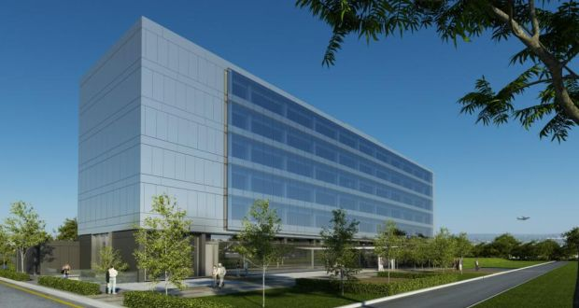



**Region 8**

**Confirmation Registration Form**

|  |  |
| --- | --- |
| Institution Name |  |
| Team Name (optional) |  |
| Coach 1 |  |
| Coach 2 |  |
| **Contact details** |  |
| Team Member 1 |  |
| Team Member 2 |  |
| Team Member 3 |  |
| Team Member 4 |  |
| **Note any special dietary requirements:** |  |

Please return to [sonya.meekel@dit.ie](mailto:sonya.meekel@dit.ie) no later than Friday October 30th