

**REGION 8**

**Inaugural Student Competition**

**Brief**

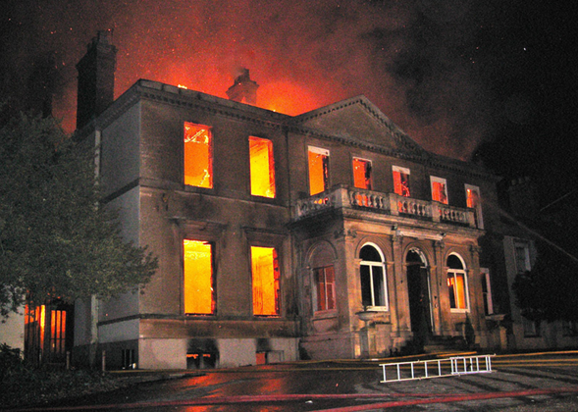

**Issued on April 24th 2014**

**Introduction:**

Health and safety forms an important strand in the design and construction process. It is essential for all current and indeed future construction professionals to have a sound understanding of health and safety and to be able to incorporate this knowledge into their projects.

For the purpose of the competition you will be taking on the roles of Contractor and must work together to achieve the project goals.

The competition information pack issued to the teams consists of:

* the brief,
* project drawings, and
* an outline description of the works to be carried out.

Construction projects will often set Contractors unique challenges with regards to the management of health and safety. We hope you enjoy the challenge we have set out for your team and we look forward to receiving your submissions.

Good luck with the project!

**ASC Region 8 Committee**

1. **SCENARIO**

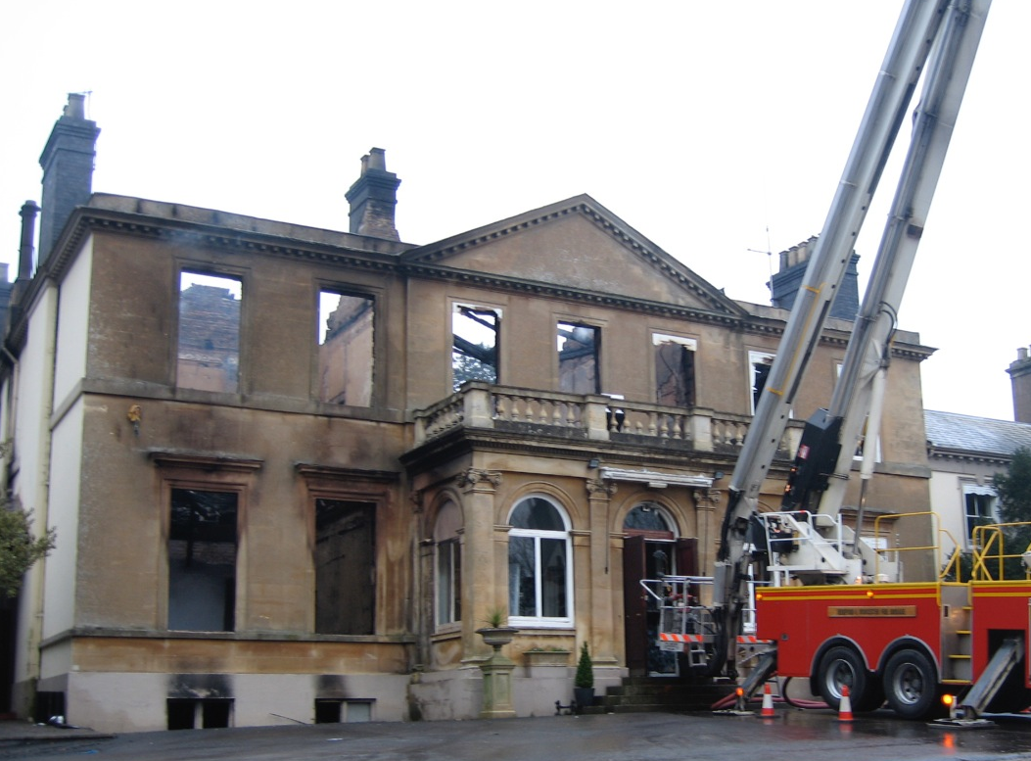

The historic building shown above has been badly damaged by fire.

**Extent of Damage**

Reference is made to the Fire Certificate Plans for location purposes (photographs).

The entire roof of the main building has been burnt away. Fragments of charred structure remain in places but the larger part of the roof structure has been consumed by the fire or has collapsed (Photographs 1, 2, 7 & 8).

The masonry walls remain intact except for a first floor wall which is suspended on a timber beam above the ‘David Shepherd Room’. The beam has deflected and has caused the wall to crack and become unstable (Photographs 9 & 10).

A further wall, above the dividing wall between the ‘David Shepherd Room’ and ‘Harcourt Webb Room’ has become unstable locally to a door-pier (Photograph 11) and has a charred timber built-in at first floor level, reducing the thickness of the wall to 105mm.

The first floor has been destroyed at the left and centre but remains intact to the right, above the bar, service area and rear right dining room. In other areas, remaining beams are badly charred and unstable (Photograph 13).

The stone stair and balcony landing have been lost, either to fire or falling roof structure (Photograph 12).

The ground floor walls have been damaged by burning of timber lintels and by thermal expansion of steel lintels. There is significant cracking of the piers supporting the steel beam over the ‘Harcourt Webb Room’ (Photograph 15). This beam has plates welded to its bottom flange, which have buckled (Photograph 16).

Timber lintels and timber fixing blocks have burnt away or are severely charred (Photograph 17).

There is a pair of thick-flanged steel joists supporting the opening between the ‘David Shepherd Room’ and the ‘Harcourt Webb Room’.

There is bearing damage and cracking above this beam (Photograph 18).

The cellar is largely brick-arched but has timber floors to the right part and to the majority of the ‘David Shepherd Room’. The front left corner of the floor in the bar area has collapsed, as has the forward part of the floor in the ‘David Shepherd Room’ (Photograph 14).

The main external walls are virtually undamaged, save for thermal cracking to the rear (photograph 5) and damage to the rear bay (photograph 6). Timber lintels to the interior stone-faced brickwork have been extensively charred, however, and eaves structure damaged by rotation and collapse of the roof structure.

The internal full-height walls are intact, but damaged by lintel expansion and burning. There is some instability of openings to the wall dividing the ‘Print Room’ and ‘Spare Office’ and severe instability to the suspended wall dividing the ‘Spare Office’ from the ‘Marketing Office’. Collapse of these walls could cause significant distortion to the external sidewall, if allowed to occur.

**Stability of remaining structure**

The external walls and full-height internal walls are stable and can be self-supporting if protected from weather. Any delay in provision of protection will allow deterioration and lessen the possibility of restoration.

The right hand first floor can be saved only if immediate weather protection is provided. It is stable at present but will suffer if not protected from moisture urgently.

The left and central areas of the first floor and the few remaining roof members should be brought down carefully and removed.

The internal first floor wall between the ‘Print Room’ and ‘Spare Office’ requires demolition to first floor level.

The suspended first floor wall above the ‘David Shepherd Room’ is damaged beyond repair. It is unstable and requires urgent demolition to prevent a collapse. If allowed to collapse, it would damage the adjoining left external wall, possibly bringing part of it and the internal wall down with it.

The arched cellars appear to be safe. The timber floor to the ‘David Shepherd Room’ has to be replaced, as does most of the floor to the bar area.

The right hand circular chimneys are unstable. The left hand brick chimneys have been ‘under-cut’. Urgent action is necessary to provide a weather-tight perimeter and covering to the remains. The building remains unsafe until the left side internal walls are demolished to first floor level. It is also necessary to remove remaining damaged roof and floor timbers.

1. **DRAWINGS/INFORMATION**

|  |  |
| --- | --- |
| **Drawings** | |
| SK14.2.07 | Details of Vaulted Brick Cellars |
| 10 | Basement Plan as existing |
| 11 | Ground Floor Plan as existing |
| 13 | First Floor Plan as existing |
| 14 | Roof Plan as existing |
| 08 | Roof Plan as existing |
| 18 | Existing East Elevation 1 of 2 |
| 19 | Existing East Elevation 2 of 2 |
| 6 | Existing Elevations |
| 20 | Existing North Elevation |
| 17 | Existing South Elevation |
| 15 | Existing West Elevation 1 of 2 |
| 16 | Existing West Elevation 2 of 2 |

|  |  |
| --- | --- |
| **Other information** | |
| Ordnance Survey Map | West Midland Safari Park Map |
| Photos – no location | Photos – with location |
| Survey photos T.07.07 | Pre and Post Fire Photos – STWD 3182.2 |

1. **RESTORATION WORK REQUIRED**

Urgent action is necessary to provide a weather-tight perimeter and covering to the remains, so it may be considered for restoration. The building remains unsafe until the above works are undertaken.

The left side internal walls are demolished to first floor level. It is also necessary to remove remaining damaged roof and floor timbers. The circular chimneys to the right side are unstable and should be taken down.

**Competition Questions**

Your team has been selected to compete in the final and propose solutions for this project.

The challenges you have been set are:

1. Taking into account the design and information provided and the nature of the building, prepare the **Risk Assessment** required for the above restoration works.

2. Based on your Risk Assessment, propose a **safe system of work** for the demolition and repair works.

*Set out the main challenges you see facing the construction stage and your solutions. You may submit a maximum of 2000 words and any relevant drawings, photos or sketches to illustrate how you propose to do the works safely.*

3. You are to prepare a 10 minute **PowerPoint presentation** of your above proposal.

*The competing teams will be required to present a summary of their overall findings and key messages, drawn from the information contained in the submission. The judging panel may ask questions, which will be largely based on the answers submitted. The panel may also ask questions about how your team went about tackling the brief. You will also be expected to discuss current safety and health issues in construction.*

**Draft Timetable**

10:00 Introduction Boardroom, MP 203

10:30 Group work starts (tea and coffee provided) MP 380 and MP 381

12:30 Lunch (and ASC Committee Meeting for staff) Café @ MP

14:30 Submission of proposals MP 203

14.35 Presentation preparation time (tea and coffee provided) MP 380 and MP 381

15:15 Presentations start MP 203

15:55 Final evaluation by panel MP 203

16:00 Announcement of the winner and presentation of prizes MP 203